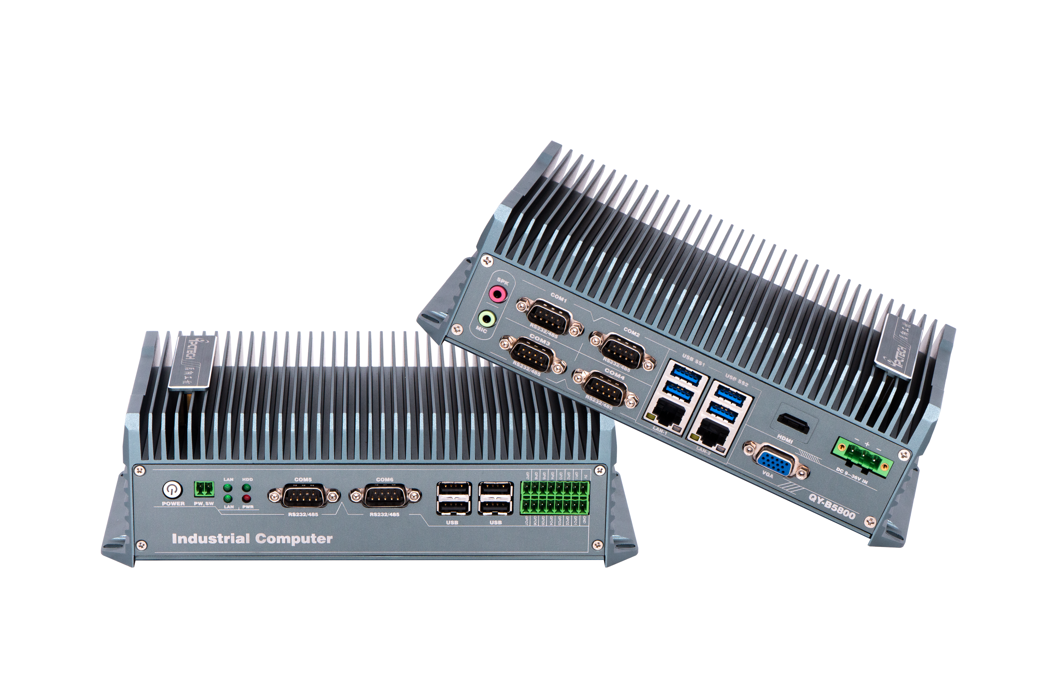
Industrial Mini PC
QY-B5800
Compound Series

Products Features:
- Industrial-Grade Embedded Fanless Mini PC
- Intel Celeron and Core 4th-i3 / i5 / i7 CPU
- 2*LAN, 8*USB, 6*COM, 1*HDMI, 1*VGA, 14*GPIO
- 2*Mini PCIE Expansion Slots, Support 4G and WIFI Module
- DC 12V Power Input With Overvoltage Protection
- -30℃~70℃ Temperature Can Keep 24/7 Work Stably
- Anti-Static, Anti-Pulse, Anti-Surge, Anti-Radiation
QY-B5800
1.Mother Board Specification:
Model | QY-B5800
CPU | J1900 / i3-4010U / i5-4260U / i7-4650U
Memory | 1*DDR III RAM Slot, Up to 8GB
Storage | 1*MSATA SSD Slot  1*SATA SSD Slots
Display | 1*HDMI: Resolution up to 3280*2000@60Hz  1*VGA: Resolution up to 1920*1200@60Hz
Expansion | 2*Mini PCIE Slots, Support 4G and WIFI module
Ethernet | 2*Realtek 8111E LAN Chip (10 / 100 / 1000 Mbps, RJ-45 Type)
USB | 4*USB 2.0 (Type-A)  4*USB 3.0 (Type-A)
COM | 2*RS-232 / 422 / 485 (DB9 Type)  4*RS-232 (DB9 Type)
GPIO | 14 ports GPIO (7*GPI+7*GPO, Phoenix Terminal Type)
Audio | 1*Line-In+1*Line-Out

2.Device Specification:
QY-B5800
Watch Dog | Support
Power Input | DC 12V With Overvoltage Protection  (Support optional Wide Voltage Power Module)
Power Input | Support Auto-Start
Power Input | 2 Pin Phoenix Terminal Type DC Plug
Working Temperature | -30℃~70℃, Support 24/7 Working
Structure | Fully Enclosed Aluminum Alloy Material
Heat Dissipation | Fanless Design, Conduction Heat Dissipation
Installation | Desktop / Embedded / Wall Mount
Size | 239mm*125mm*58mm
System | Windows and Linux

QY-B5800
3.Ordering Information:
Model | CPU | LAN | USB | COM | Display | RAM | SSD | Expansion | Power
QY-B5800 | J1900 / 4th | 2 | 8 | 2*RS-232/422/485  4*RS-232 | 1*HDMI  1*VGA | 1*DDR 3  Up to 8GB | 1*MSATA  1*SATA | 2*Mini PCIE | DC 12V

4.CPU Information:

CPU | Specification
J1900 | 4 core, 4 total threads, 2.00GHz to 2.42 GHz, 2 MB cache | Max to 8GB for 1*RAM 3 slot
i3-4010U | 2 core, 4 total threads, 1.70 GHz, 3 MB cache | Max to 8GB for 1*RAM 3 slot
i5-4260U | 2 core, 4 total threads, 1.40 GHz to 2.70 GHz, 3 MB cache | Max to 8GB for 1*RAM 3 slot
i7-4650U | 2 core, 4 total threads, 1.70 GHz to 3.30 GHz, 4 MB cache | Max to 8GB for 1*RAM 3 slot

5.System Information:

CPU | System
J1900 / 4th | Windows 7 / 10 and Linux

6.Fittings Information:
RAM | DDR 3 | 4GB / 8GB
Storage | MSATA | 64GB / 128GB / 256GB / 512GB / 1TB
Storage | SATA | 120GB / 128GB / 240GB / 256GB / 480GB / 512GB / 960GB / 1TB / 2TB / 4TB
GSM Module | 4G | 4G+GPS
WIFI Module | 7260AN / 7260AC / AX210
QY-B5800
7.Package List:
Adapter | 1*12V 5A Adapter
Power Cable | 1*Power Cable
Terminal | 2 Pin phoenix terminal for Power Switch
Terminal-2 | 2*8 Pin phoenix terminal for GPIO
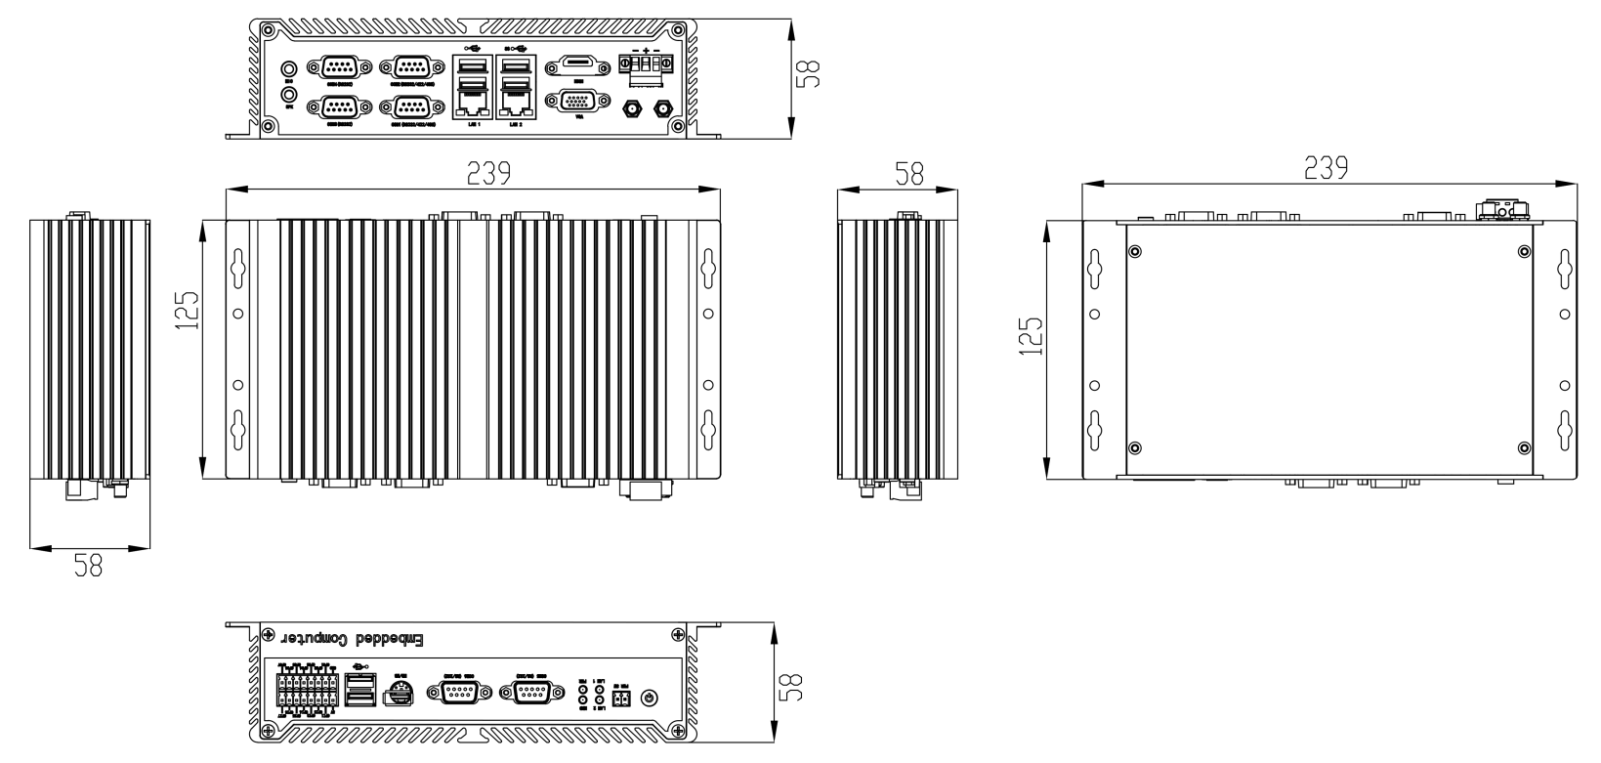
8.Dimensions:

